

American International University-Bangladesh (AIUB)

**Department of Computer Science**

**Faculty of Science &Technology (FST)**

**Spring 2020-2021**

**CSC 2210 Object Oriented Analysis and Design (OOAD)**

**Section: F  
Group No: 10**

An Object-Oriented Analysis and Design (OOAD) project submitted

By

|  |  |  |  |
| --- | --- | --- | --- |
| SL No | Student Name | Student ID | Contribution (%) |
| 01 | NAFINUR LEO | 20-42195-1 | 25% |
| 02 | MD. TANZIB HOSAIN | 20-42737-1 | 25% |
| 03 | MD. TAOHID HASAN ANIK | 20-43028-1 | 25% |
| 04 | MD. RAZIB MOLLAH | 20-42153-1 | 25% |
| 05 |  |  | 100% |

Answer: 01

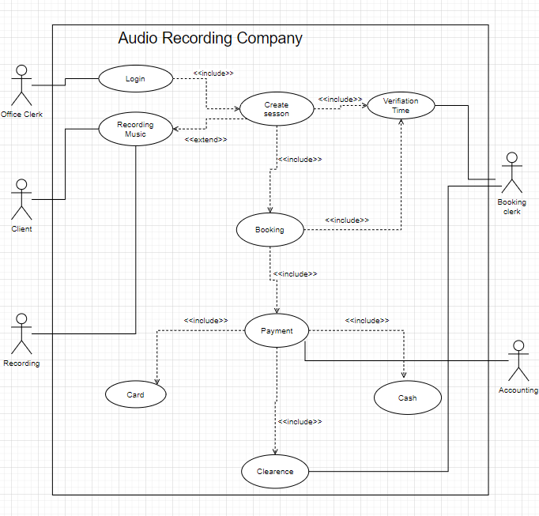

Answer: 02

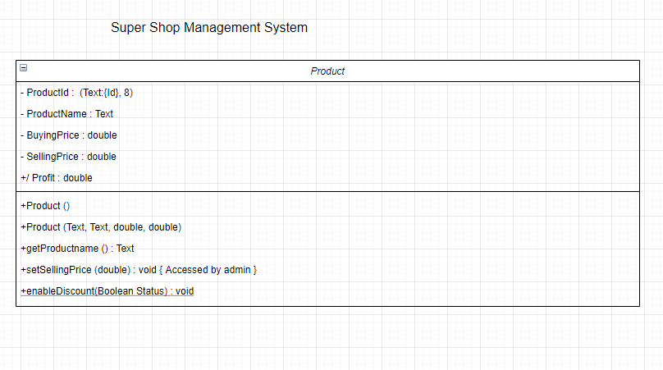

Answer: 03

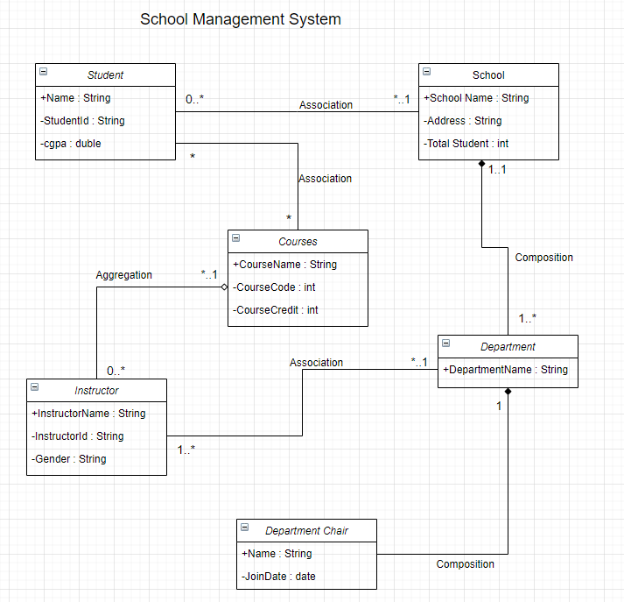

Answer: 04

